**No Pain No Planner**

**Chapter 0: Introduction**

Hello user and welcome to the user manual for the No Pain No Planner software graphics user interface. This manual will be an easy and beginner friendly step-by-step guide on how to fully utilise No Pain No Planner for your everyday workout benefits.

**Chapter 1: Home Page Navigation**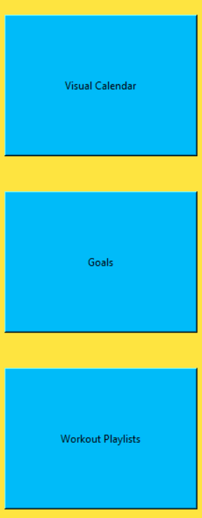

Whenever we first open the No Pain No Planner software we are greeted by three very large buttons located on the left third of the window, these buttons are the essential navigation point for moving around in our software. The top button, labelled, “Visual Calendar,” the middle button, labelled, “Goals,” and the bottom button, labelled, “Workout Playlists.”

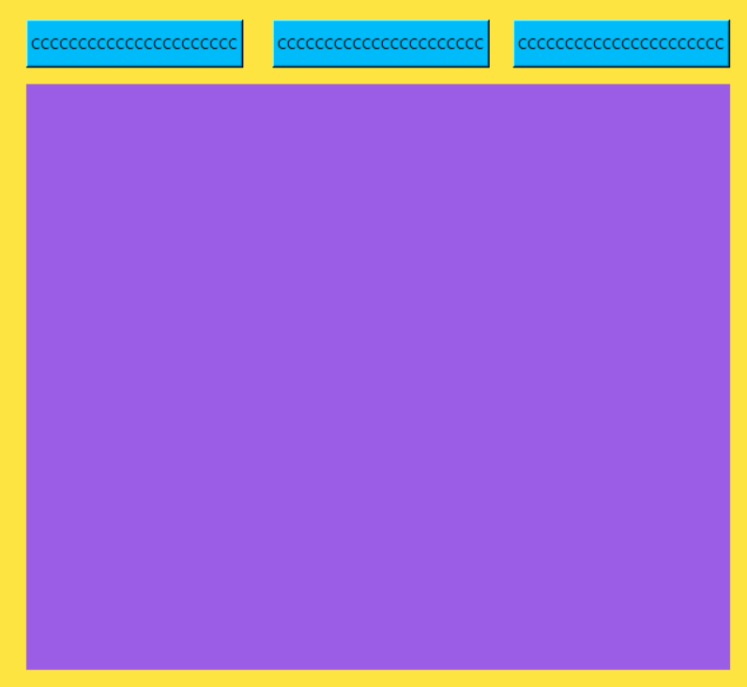

Located in the right two thirds of the software is a purple frame with three dynamic segments above it, depending on the app these segments may be used as buttons or merely as labels, they will change look and function accordingly.

**Chapter 2: Workout Playlists + Creating A Workout Playlist**

The Workout Playlists Page is where we will go to create, save, and manage playlists of workouts. The three header options for this page include Edit Playlists, Create Playlist, and View Playlists. The home page is left blank until we click on one of the header options.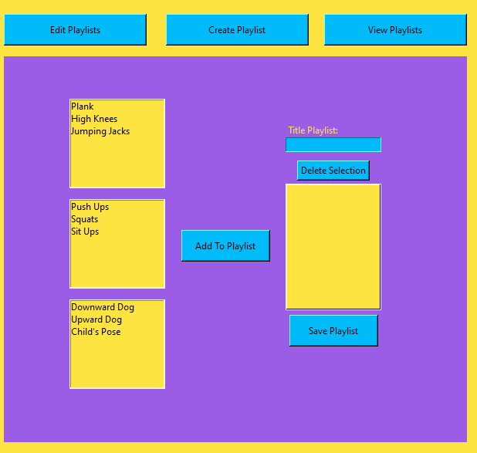

We are now beginning the practical use of the Planner. The first thing that an eager workout goer is going to want to try to do is create a playlist of workouts that interest them. We do this in the Create Playlist Page.

On the further left most portion of the purple frame we will find a few selection boxes from which we will choose which workout to add to the playlist we are creating, some options include the Plank, Jumping Jacks, Push Ups, or Child’s Pose.

The workouts are categorised in app, in Endurance, Strength, and Balance selection boxes. The top box is the Endurance category, the middle box is the Strength category, and the bottom box is the Balance category. We can only pick one workout at a time to add to our playlist. We select an option, let’s say, the Plank, and add it to our playlist by clicking on the “Add To Playlist” button, now the Balance workout known as the Plank is sitting in the right most selection box. We can continue adding workouts until we are satisfied with our playlist, and if we become unsatisfied we can easily delete an option by selecting it in our New Playlist selection box and hitting the delete button. Before saving a playlist we must title it (It technically is not necessary but best for our eyes to see later) and hit the Save Playlist button below the selection box. Now our playlist is in the database and will be available to use when we want to initiate a workout.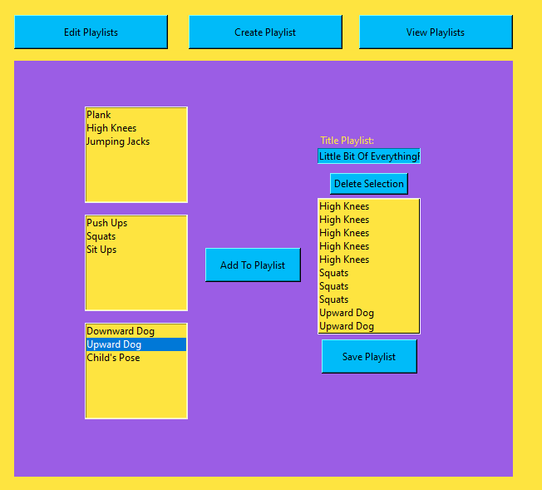

**Chapter3: View Playlists Page + Beginning A Workout**

In the View Playlists page we are able to look at any Workout Playlists we have saved ever and use them to initiate a workout. This is the easiest part, minus the actual physical effort expected of you.

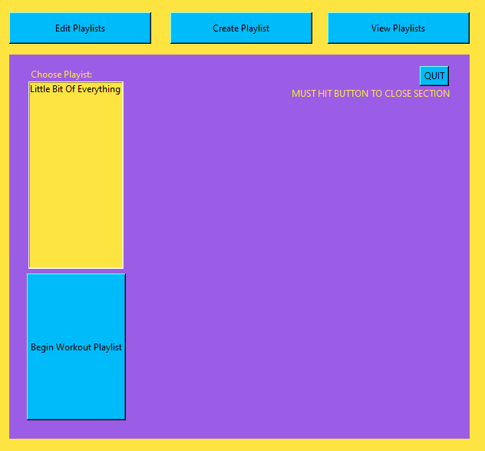

On the far left of the purple frame there is a labelled selection box, and a huge button. The selection box is the Playlist Chooser, whatever we had named our playlist in the Create Playlists page will be shown here in this selection box, all we must do now is select what we want to do, and hit the big “Begin Workout Playlist” button.

The playlist will begin and in doing so will show us the name of what we are supposed to be doing as well as a growing progress bar that will signal to us when to stop doing what we are doing and to move on to the next workout. At the end of the playlist everything we have done will be saved as we have done it today, there is no way to change what we did on a particular day in the past, but all workouts that are done today will be saved today and will be viewable in the calendar. 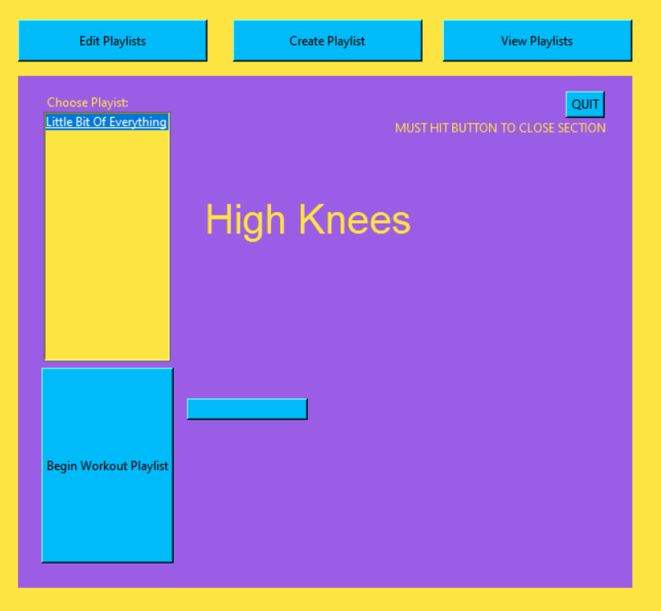

**IMPORTANT WARNING REGARDING VIEW PLAYLISTS PAGE:**

Right now there is a frame error when exiting the View Playlists page and the “QUIT” button in the top right is the only way to do so, if not pressed the page will stay loaded above everything else.

**Chapter 3: Visual Calendar**

The Calendar is by far the simplest page in the app, after the Visual Calendar button is clicked the app will show you what kinds of workouts you got done and how many of each kind you did, and if you’re a real overachiever, it’ll overflow the screen. In its current state the Visual Calendar only shows the last seven days from today and all the workouts you did those days, from 0 to infinity.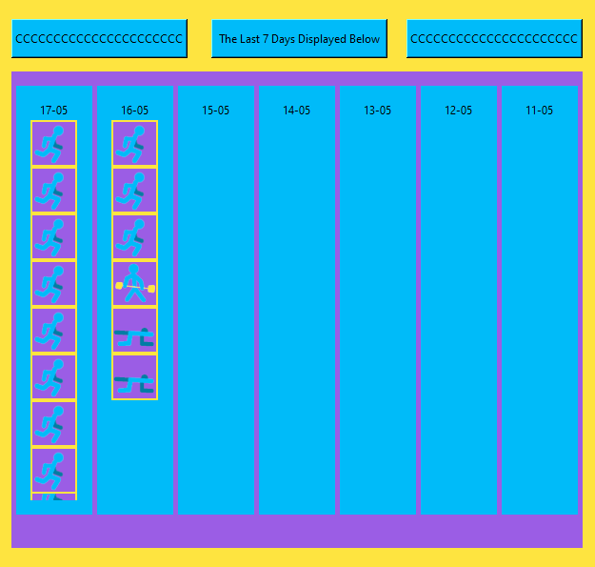

You can tell which type of workout was done based on the image provided, they are in order by completion.

This image signifies Endurance: 



This image signifies Strength:



This image signifies Balance:

We can see that on 16-05 we completed 6 workouts, 3 of which were endurance workouts, one of which was a strength workout, and two of which were balance workouts.

**Chapter 4: Conclusion**

That was a comprehensive and beginner friendly guide on how to use the No Pain No Planner software and all of its current usability. The Goals page has not been implemented, nor has the Edit Playlists page, but everything else is in working order. It is time for you to get your workout on.